This document acts as a runbook for running the migration scripts for storm 2.0

Pre-requisites
Here are certain pre-requisites to start with the migration scripts:
- Ensure python is installed in the system.
- PAT token details of site admin creator level or above account on source and target.
- The source and tableau cloud are accessible from your system.
- The project path specified as the destination is already present on tableau cloud.
- Microsoft Excel and Notepad for modifying the config and mapping files should be present on the system.

Data Source Migration

Download the zip file shared.
- Extract all the content to the desired location.
- Open the file config.xml.
- Update the login details in the config file including server & cloud URLs, PAT, Site and Postgres database details.
    - Server URL:
    - Cloud URL:
    - PAT:
      - Create [pat
      - Copy
    - Site
    - Postgres database:
      - Port
      - Server
      - Username
      - Password
- Among the content unpacked in step 2, move to the folder named like “dist”
- You should be able to see a file named <storm 1.0.0.tar>
- Open the command prompt in this directory and run the command – pip install storm1.0.0.tar.
- The .tar file name might be slightly different, adjust the command accordingly.
- To migrate the data sources, run the following commands
  - create-project-mapping-excel --r <” location of config file”>
  - this will create an excel file with project path on the source, as shown below:
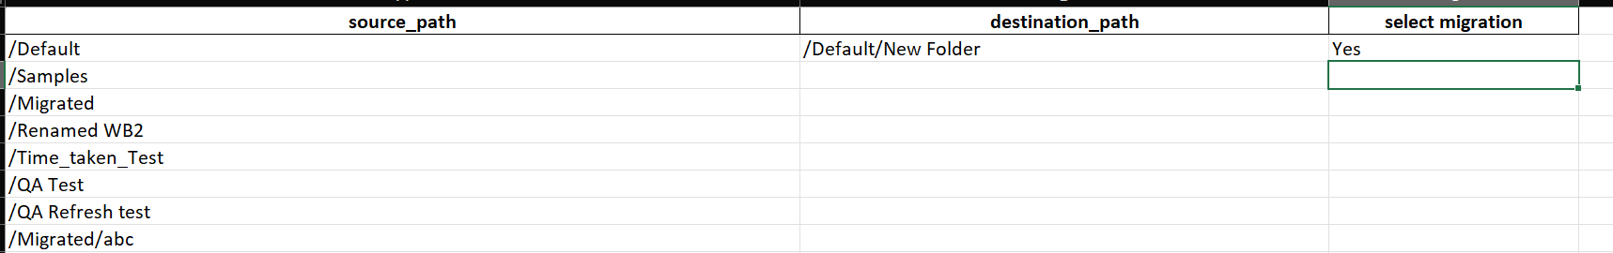
  - The file contains 3 columns – source_path – project path on source server, destination_path – this needs to be updated manually with desired project path
  - After selecting the projects and mentioning the destination path.
  - Run the command, create-data source-excel --config <"location of the config file”>
  - This will generate an excel called datasource_path.
  - Once, the excel is generated, run this command: datasource-migrate --config <” location of config file”> --project <” location of project mapping file”>
- Once the execution is done, you can verify the migrated data sources in the excel generated as migration logs.

Workbook Migration

Download the zip file shared.
- Extract all the content to the desired location.
- Open the file config.xml.
- Update the login details in the config file including server & cloud URLs, PAT, Site and Postgres database details.
- Among the content unpacked in step 2, move to the folder named like “dist”
- You should be able to see a file named <storm 1.0.0.tar>
- Open the command prompt in this directory and run the command – pip install storm1.0.0.tar.
- The .tar file name might be slightly different, adjust the command accordingly.
- To migrate the workbooks, run the following commands
  - create-project-mapping-excel --r <” location of config file”>
  - This will create an excel file with project path on the source, as shown below:

  - The file contains 3 columns – source_path – project path on source server, destination_path – this needs to be updated manually with desired project path
  - After selecting the projects and mentioning the destination path.
  - Run the command, create-data source-excel --config <"location of the config file”>
  - This will generate an excel called datasource_path.
  - Once, the excel is generated, run this command: workbook-migrate --config <” location of config file”> --project <” location of project mapping file”>
- Once the execution is done, you can verify the migrated workbooks in the excel generated as migration logs.

Extract Refresh Migration

Download the zip file shared.
- Extract all the content to the desired location.
- Open the file config.xml.
- Update the login details in the config file including server & cloud URLs, PAT, Site and Postgres database details.
- Among the content unpacked in step 2, move to the folder named like “dist”
- You should be able to see a file named <storm 1.0.0.tar>
- Open the command prompt in this directory and run the command – pip install storm1.0.0.tar.
- The .tar file name might be slightly different, adjust the command accordingly.
- To migrate the workbooks, run the following commands
  - create-project-mapping-excel --r <” location of config file”>
  - This will create an excel file with project path on the source, as shown below:

  - The file contains 3 columns – source_path – project path on source server, destination_path – this needs to be updated manually with desired project path
  - After selecting the projects and mentioning the destination path.
  - Run this command: extract-schedule-migrate --config <” location of config file”> --project <” location of project mapping file”>
- Once the execution is done, you can verify the migrated extract schedules in the excel generated as migration logs.

Project Migration

Download the zip file shared.
- Extract all the content to the desired location.
- Open the file config.xml.
- Update the login details in the config file including server & cloud URLs, PAT, Site and Postgres database details.
- Among the content unpacked in step 2, move to the folder named like “dist”
- You should be able to see a file named <storm 1.0.0.tar>
- Open the command prompt in this directory and run the command – pip install storm1.0.0.tar.
- The .tar file name might be slightly different, adjust the command accordingly.
- To migrate the Projects, run the following commands
  - create-user-mapping-file --config <location of config file>
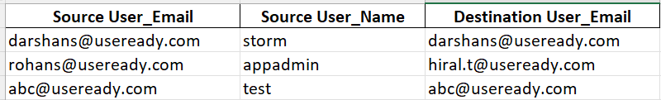
  - Map the users as per the requirement in the “User_Mapping” excel generated post running the first command.

  - create-project-mapping-file --config
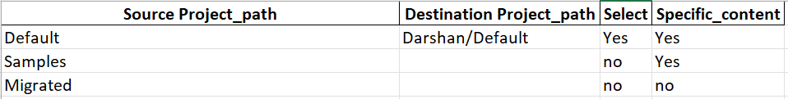
  - In the “Project Path” excel Mention Project Path if the desired path for project creation is different, in case of same desired location we do not need to specify path. Only add 'Yes' in the 'Specific_content' column.

